NETFLIX DATA ANALYSIS
- First, I created a NETFLIX database using SQL prompt.
- Secondly, I imported all the data using task>Import data> using Flat file.
- Allocated respective data type according to data.
- We can also create data base using queries and import all the data by doing so.
- To verify the data is correctly imported, please refer to the below visual.
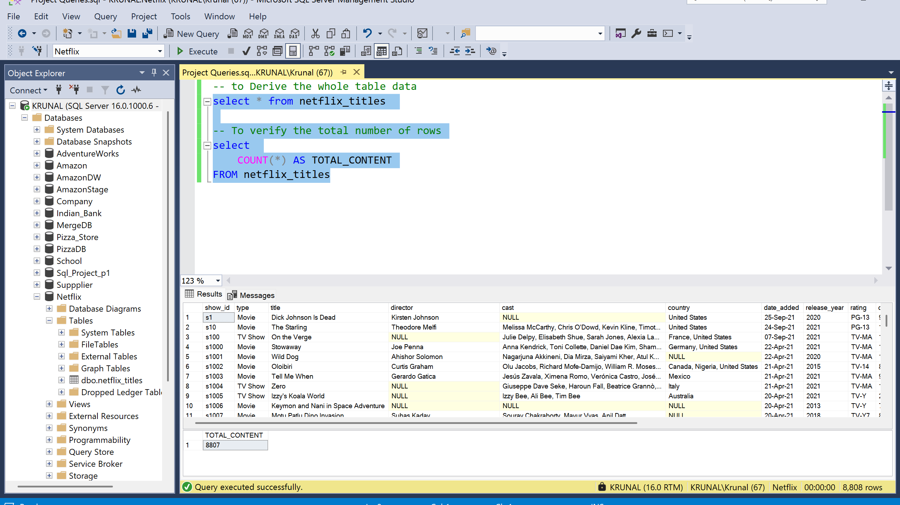
- We can verify the data is correctly imported using the queries we ran above inside SQL server studio.
- Now, we can perform different operations on this data to get the insights of the business segments or analysis of the movies.

- To find different category inside types.
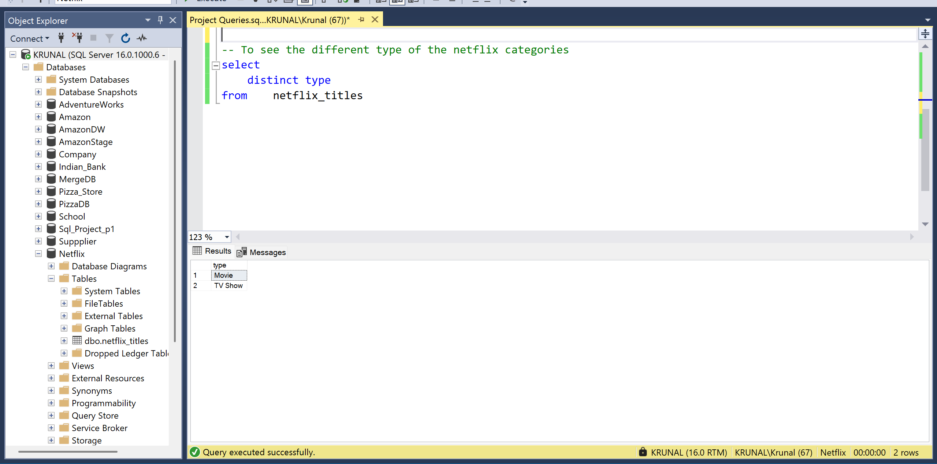
- To find all the null values within dataset.
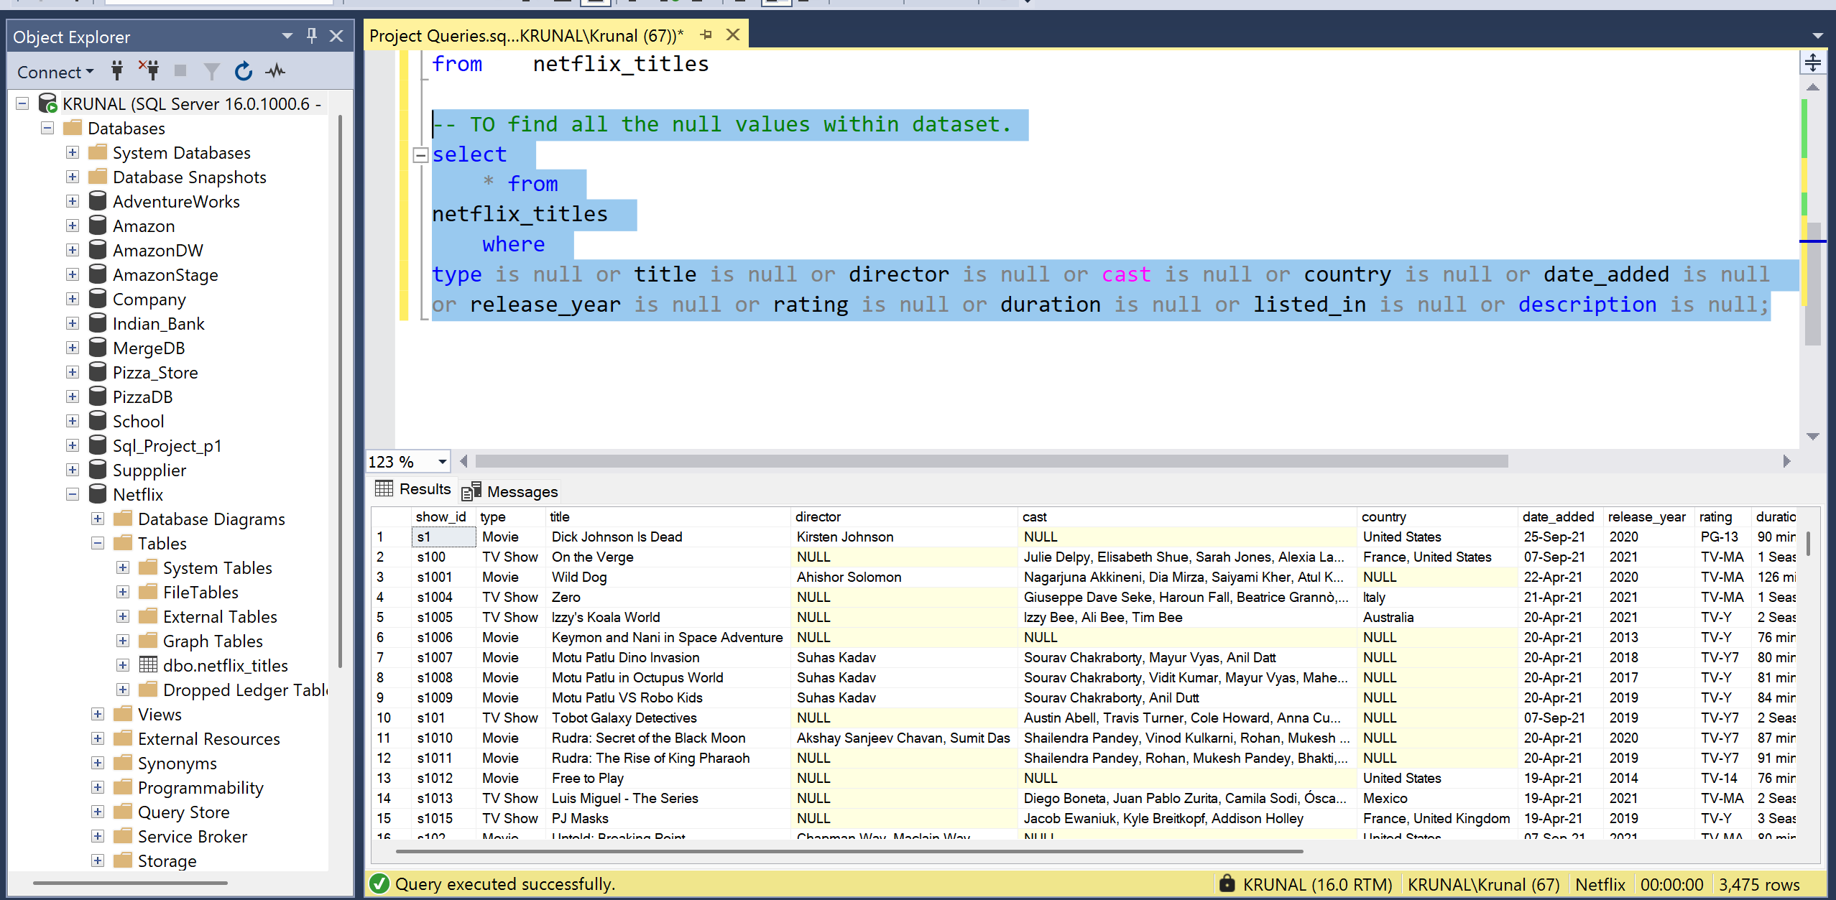

- 1. Count the number of Movies vs TV Shows

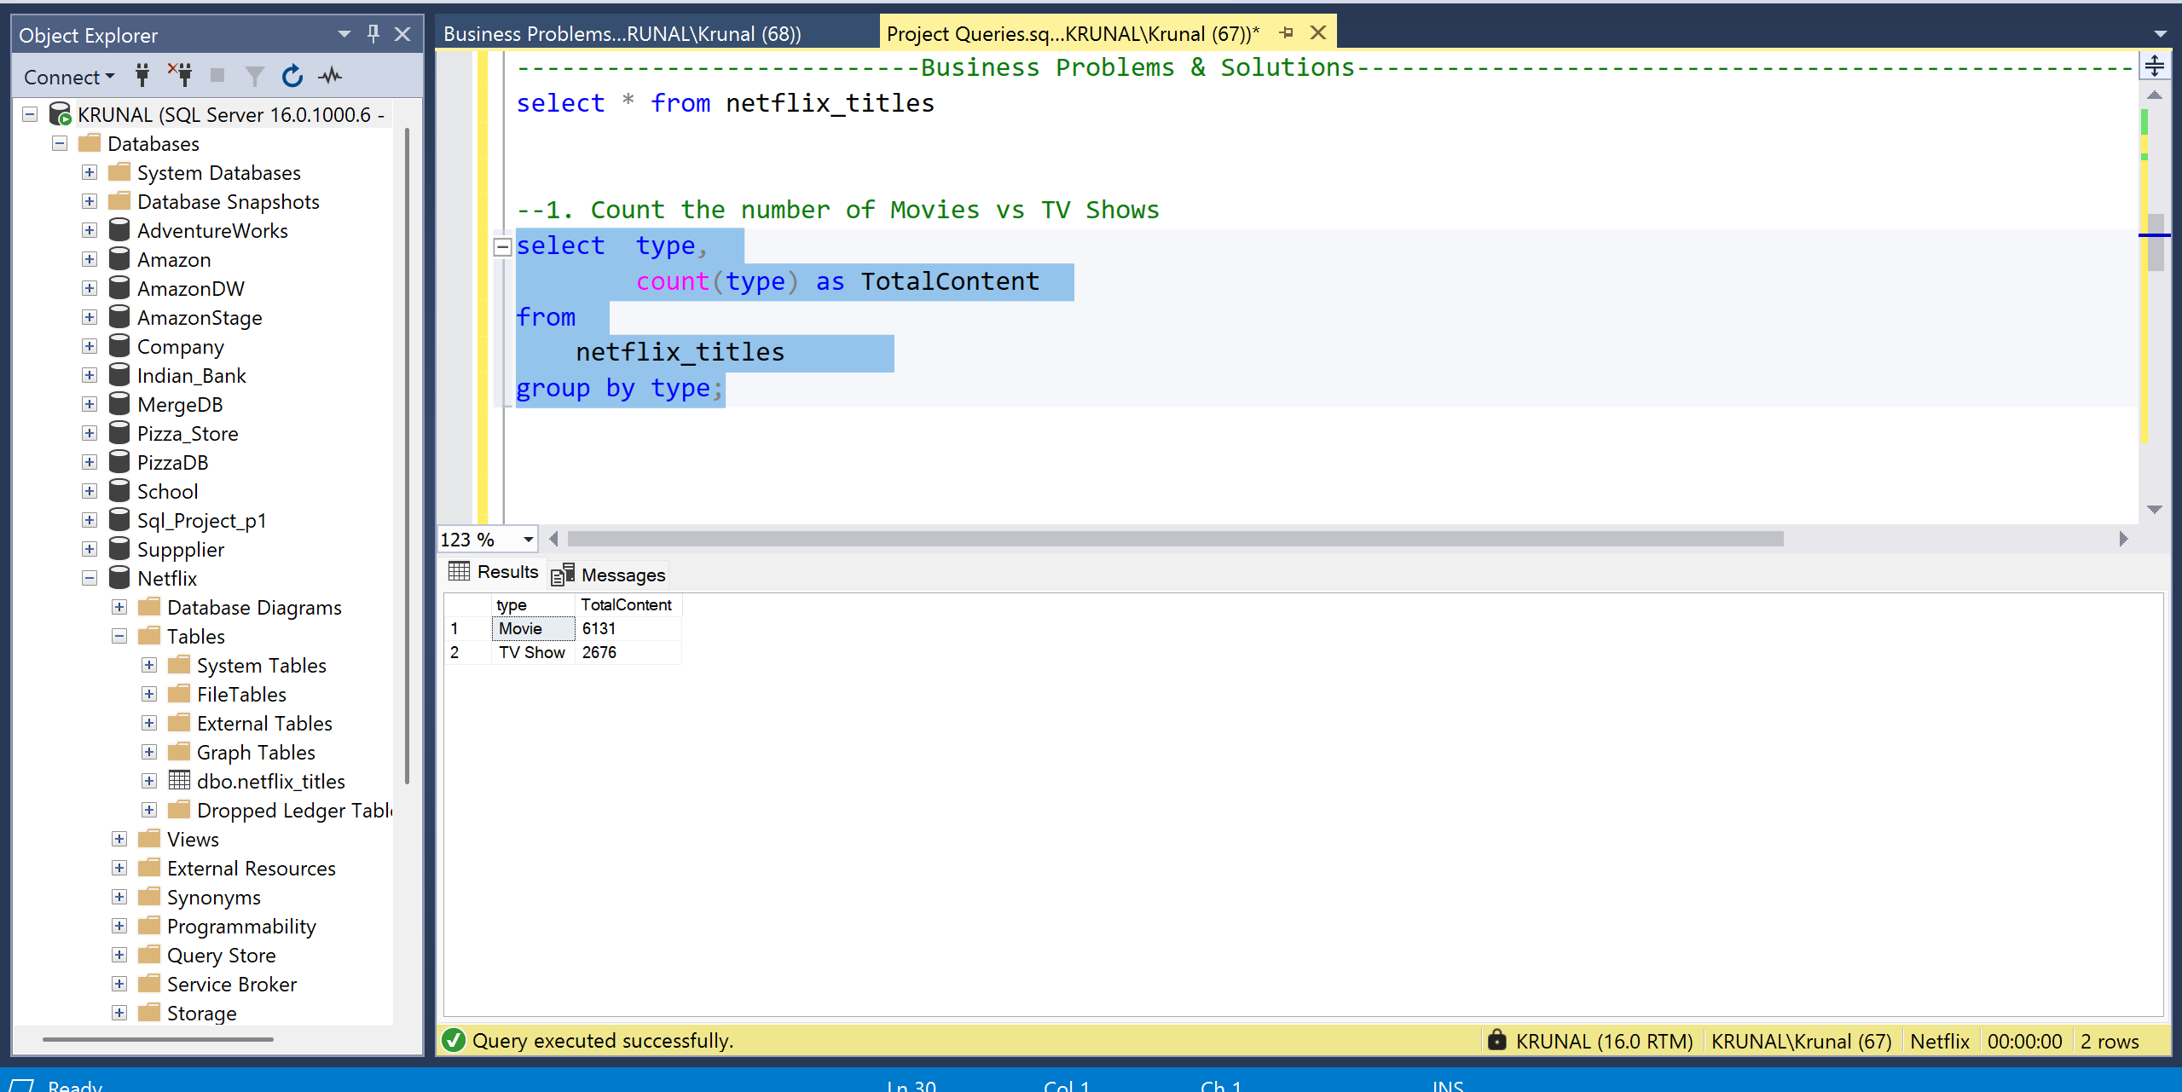

- 2. Find the most common rating for movies and TV shows

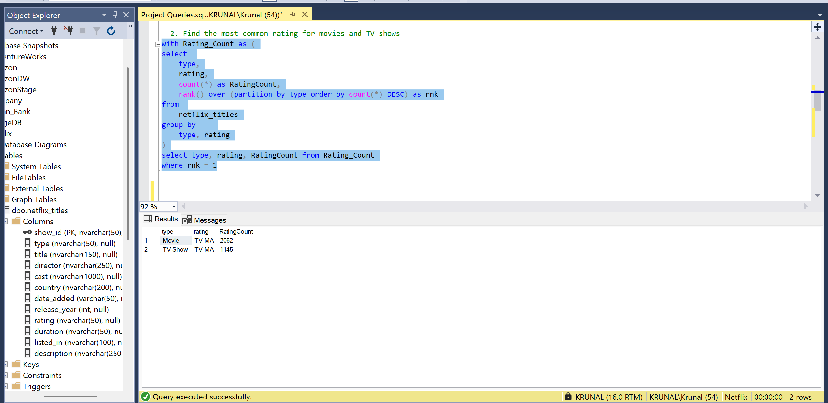

- --3. List all movies released in a specific year (e.g., 2020)
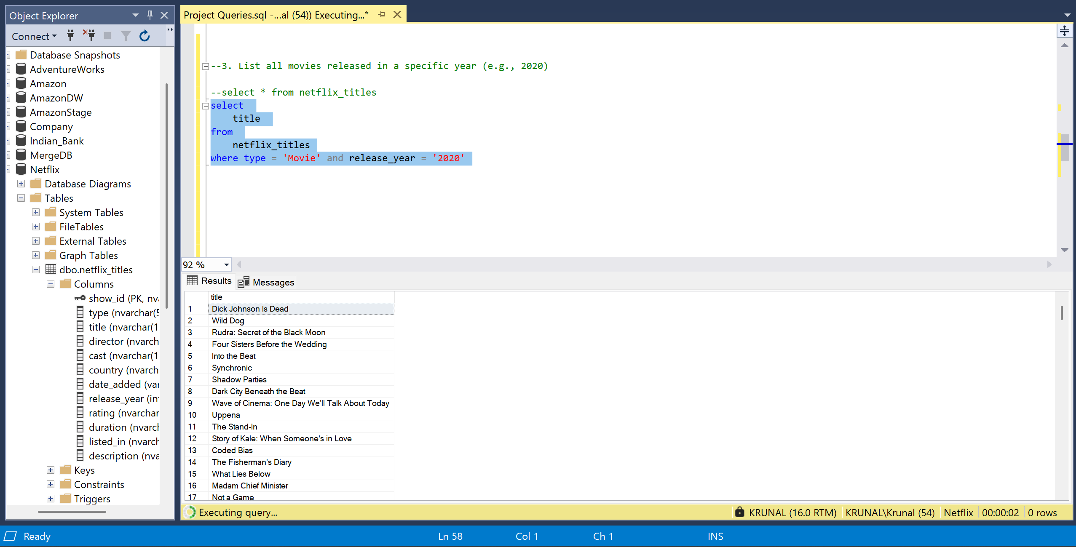

- --4. Find the top 5 countries with the most content on Netflix

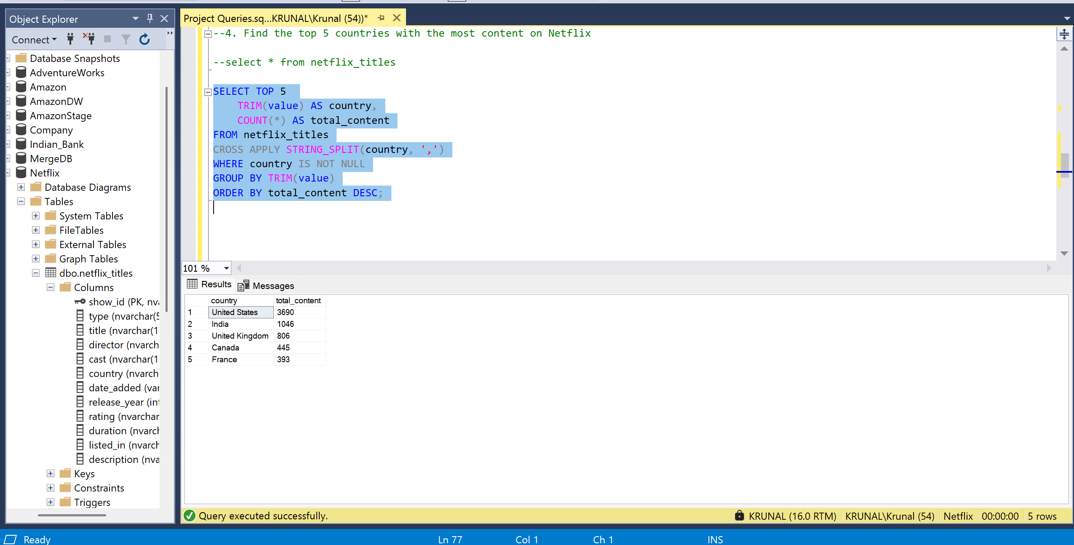

--5. Identify the longest movie
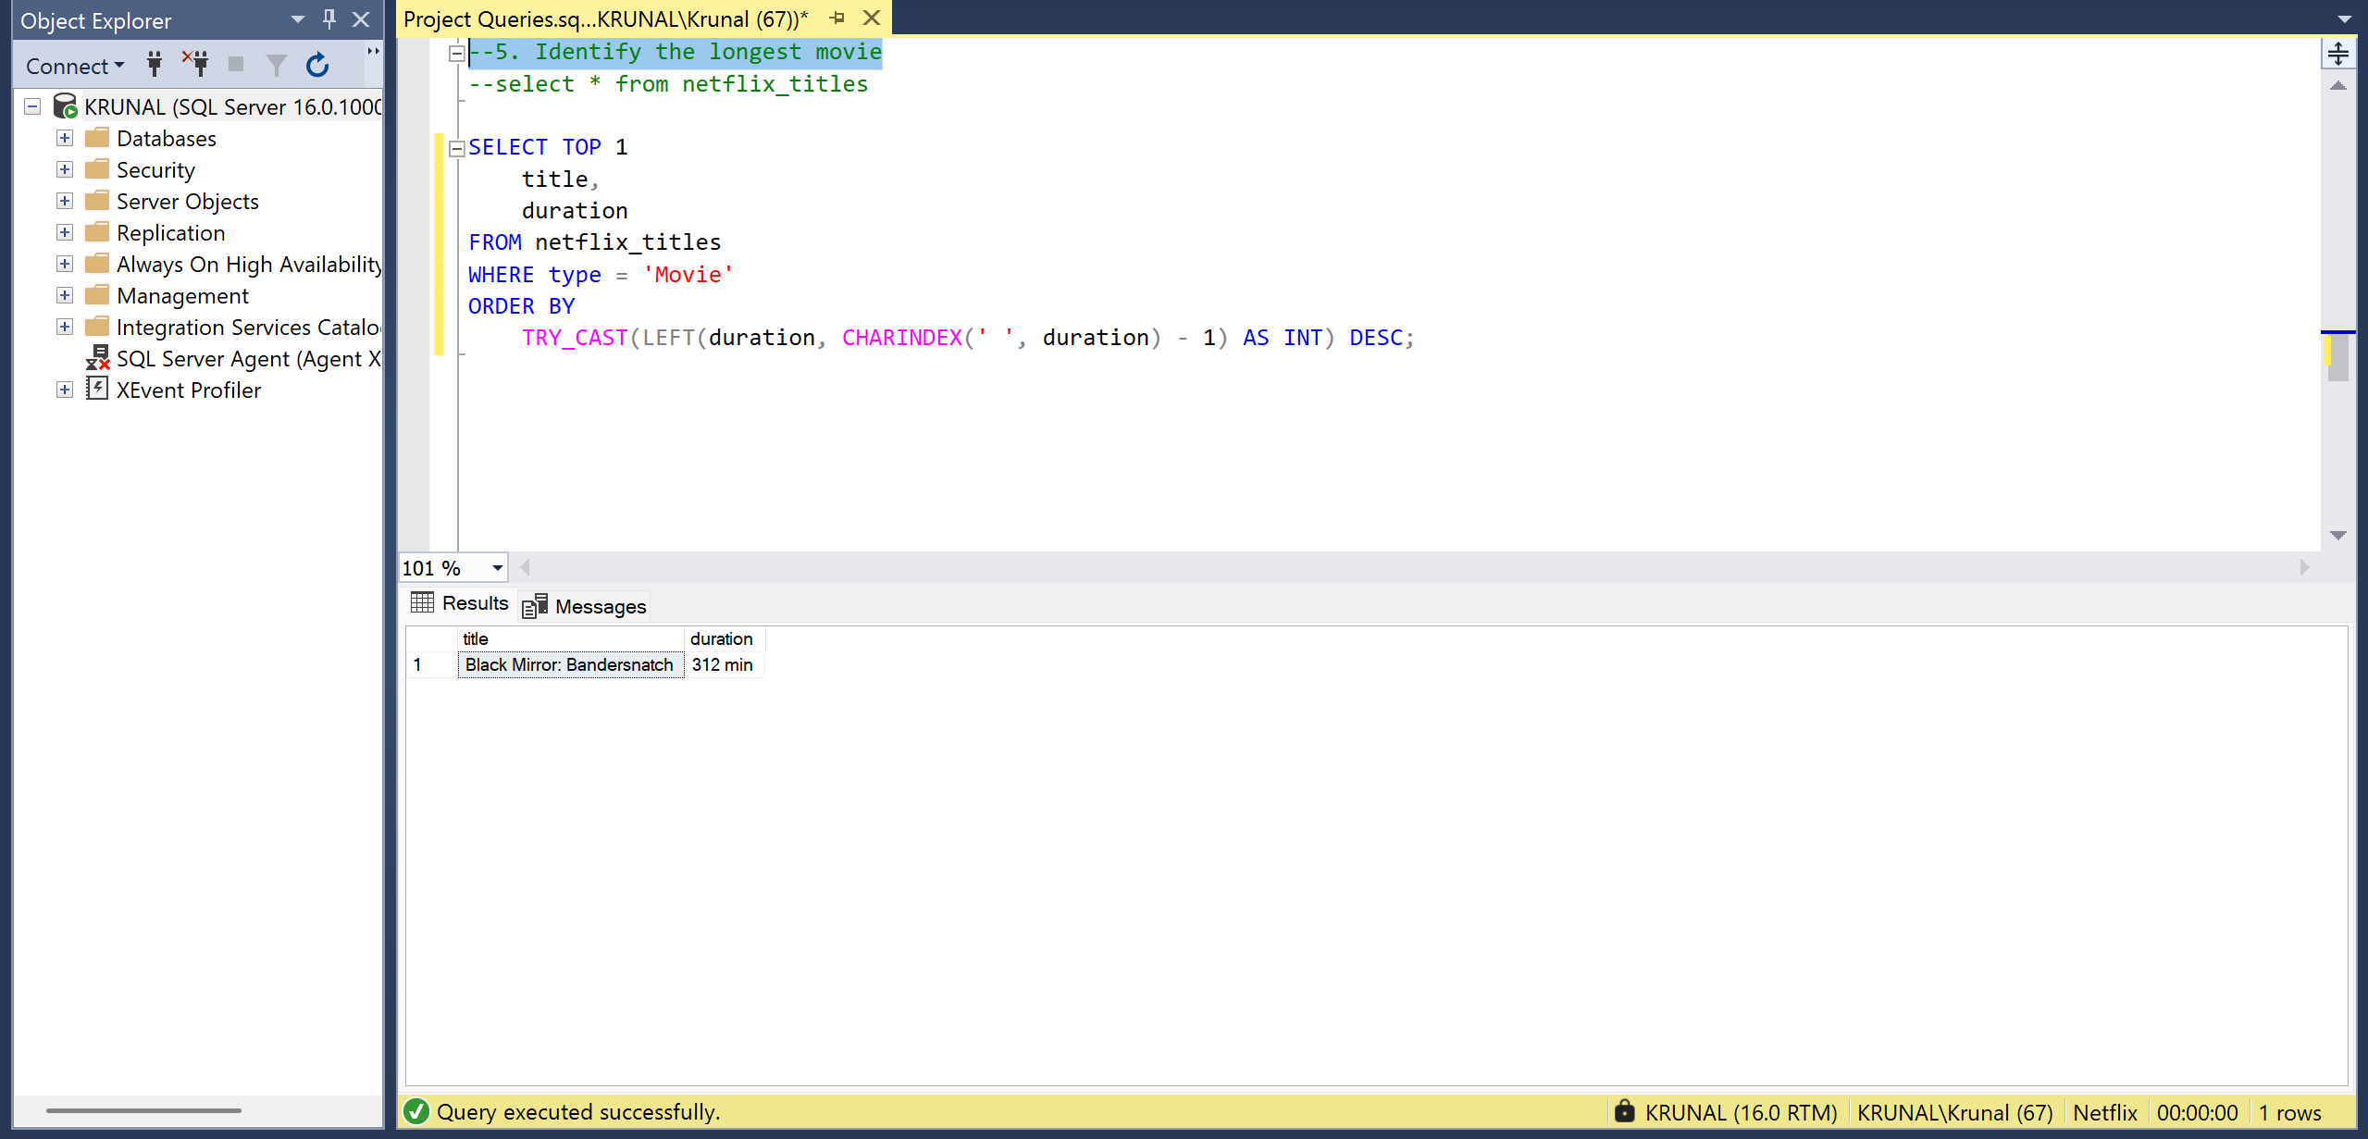

- --6. Find content added in the last 5 years
- Why use TRY_CAST instead of CAST?
- TRY_CAST prevents query failure if some date values are invalid or NULL.

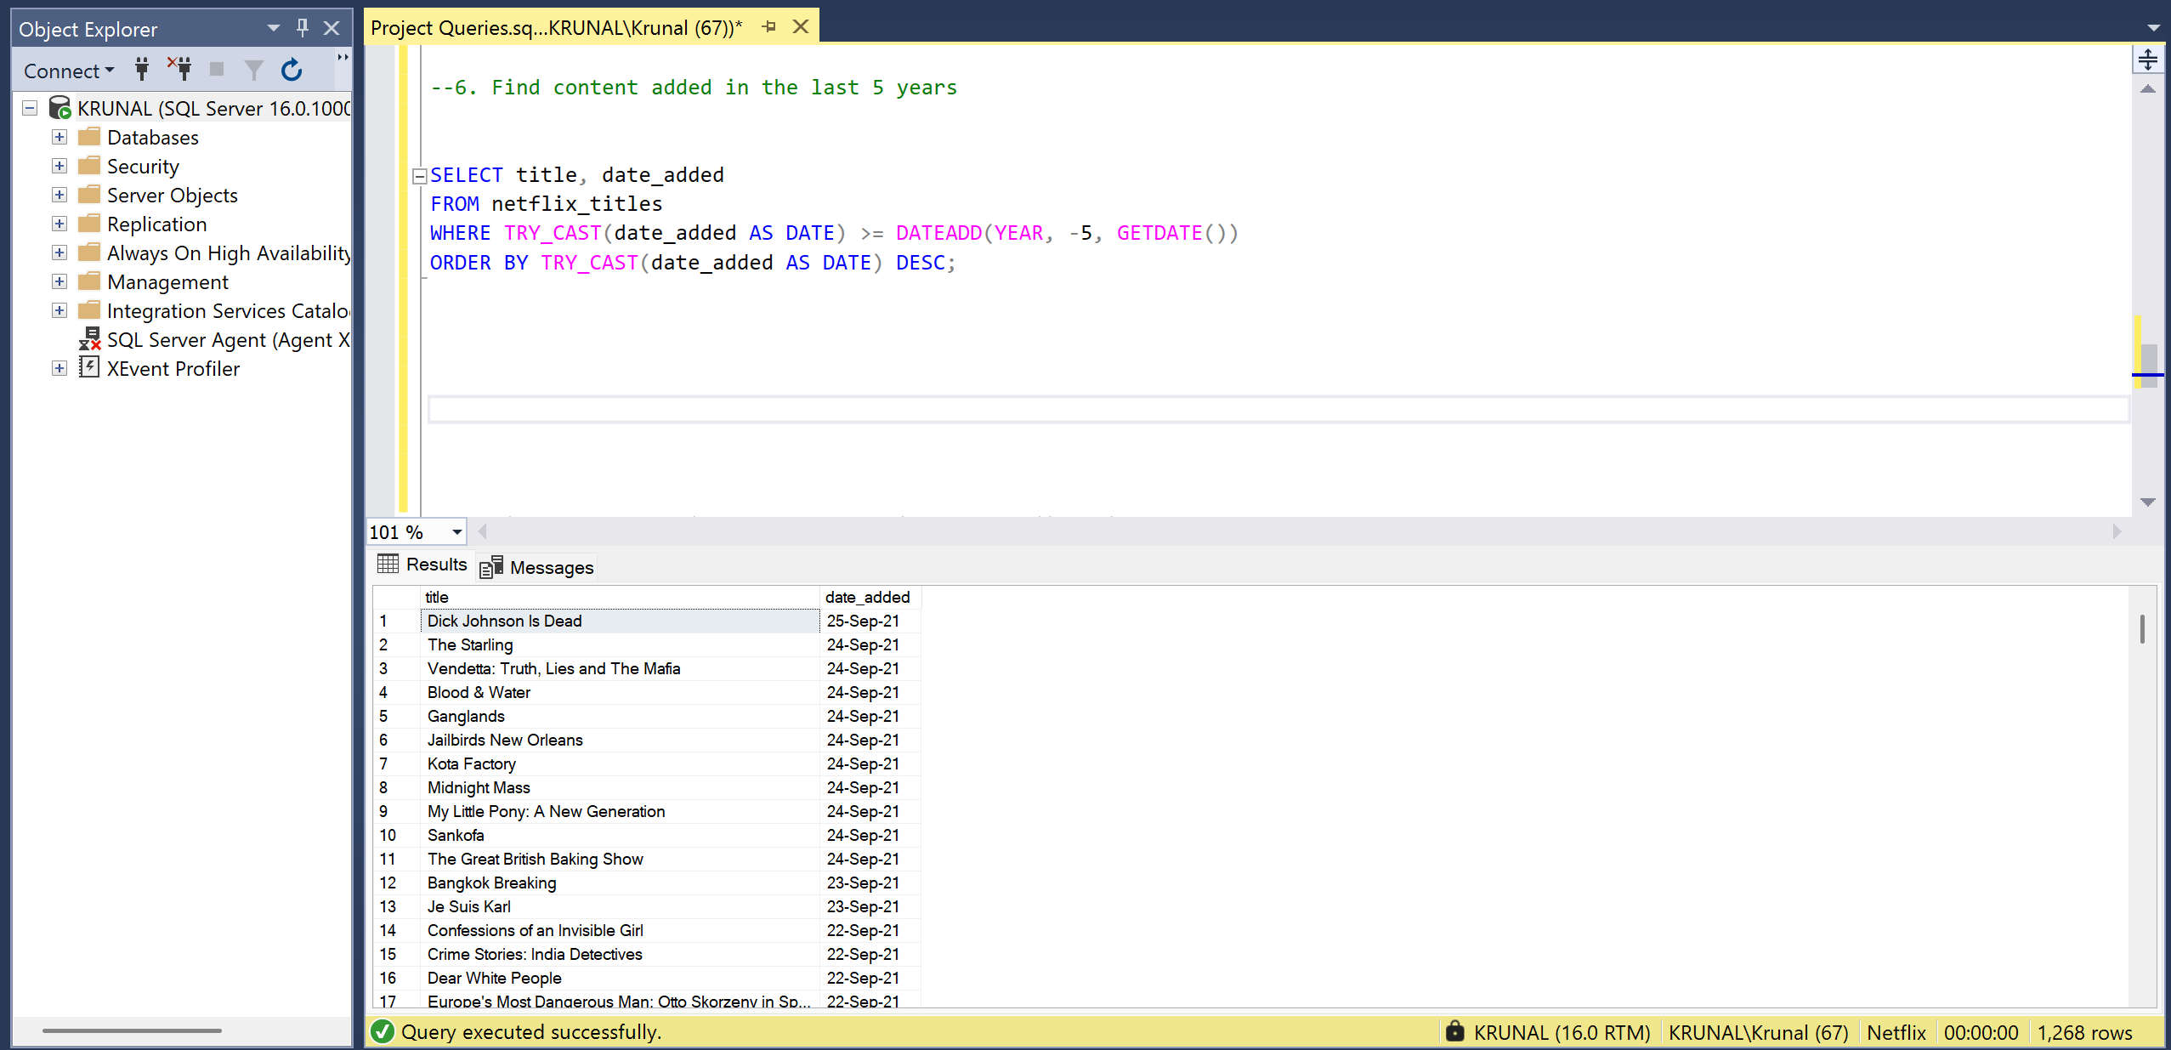

- --7. Find all the movies/TV shows by director 'Rajiv Chilaka'!

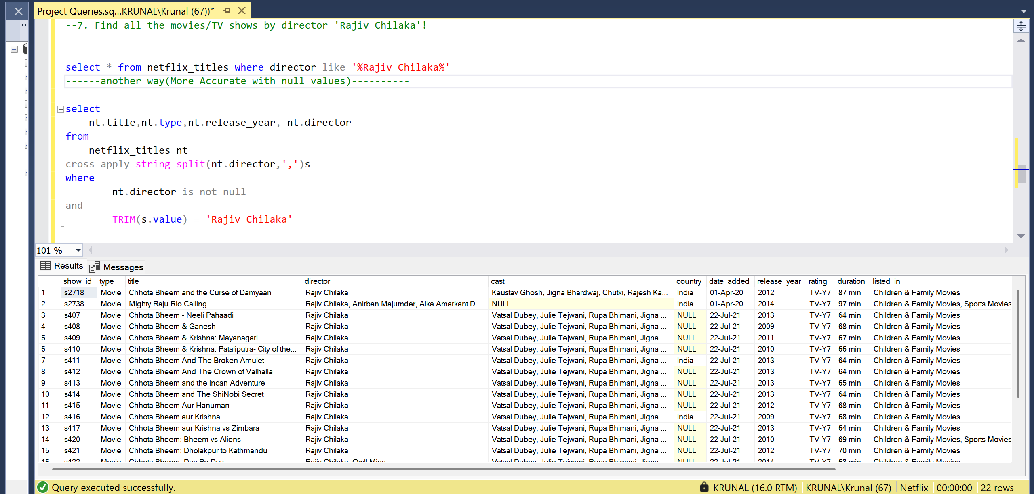

--8. List all TV shows with more than 5 seasons

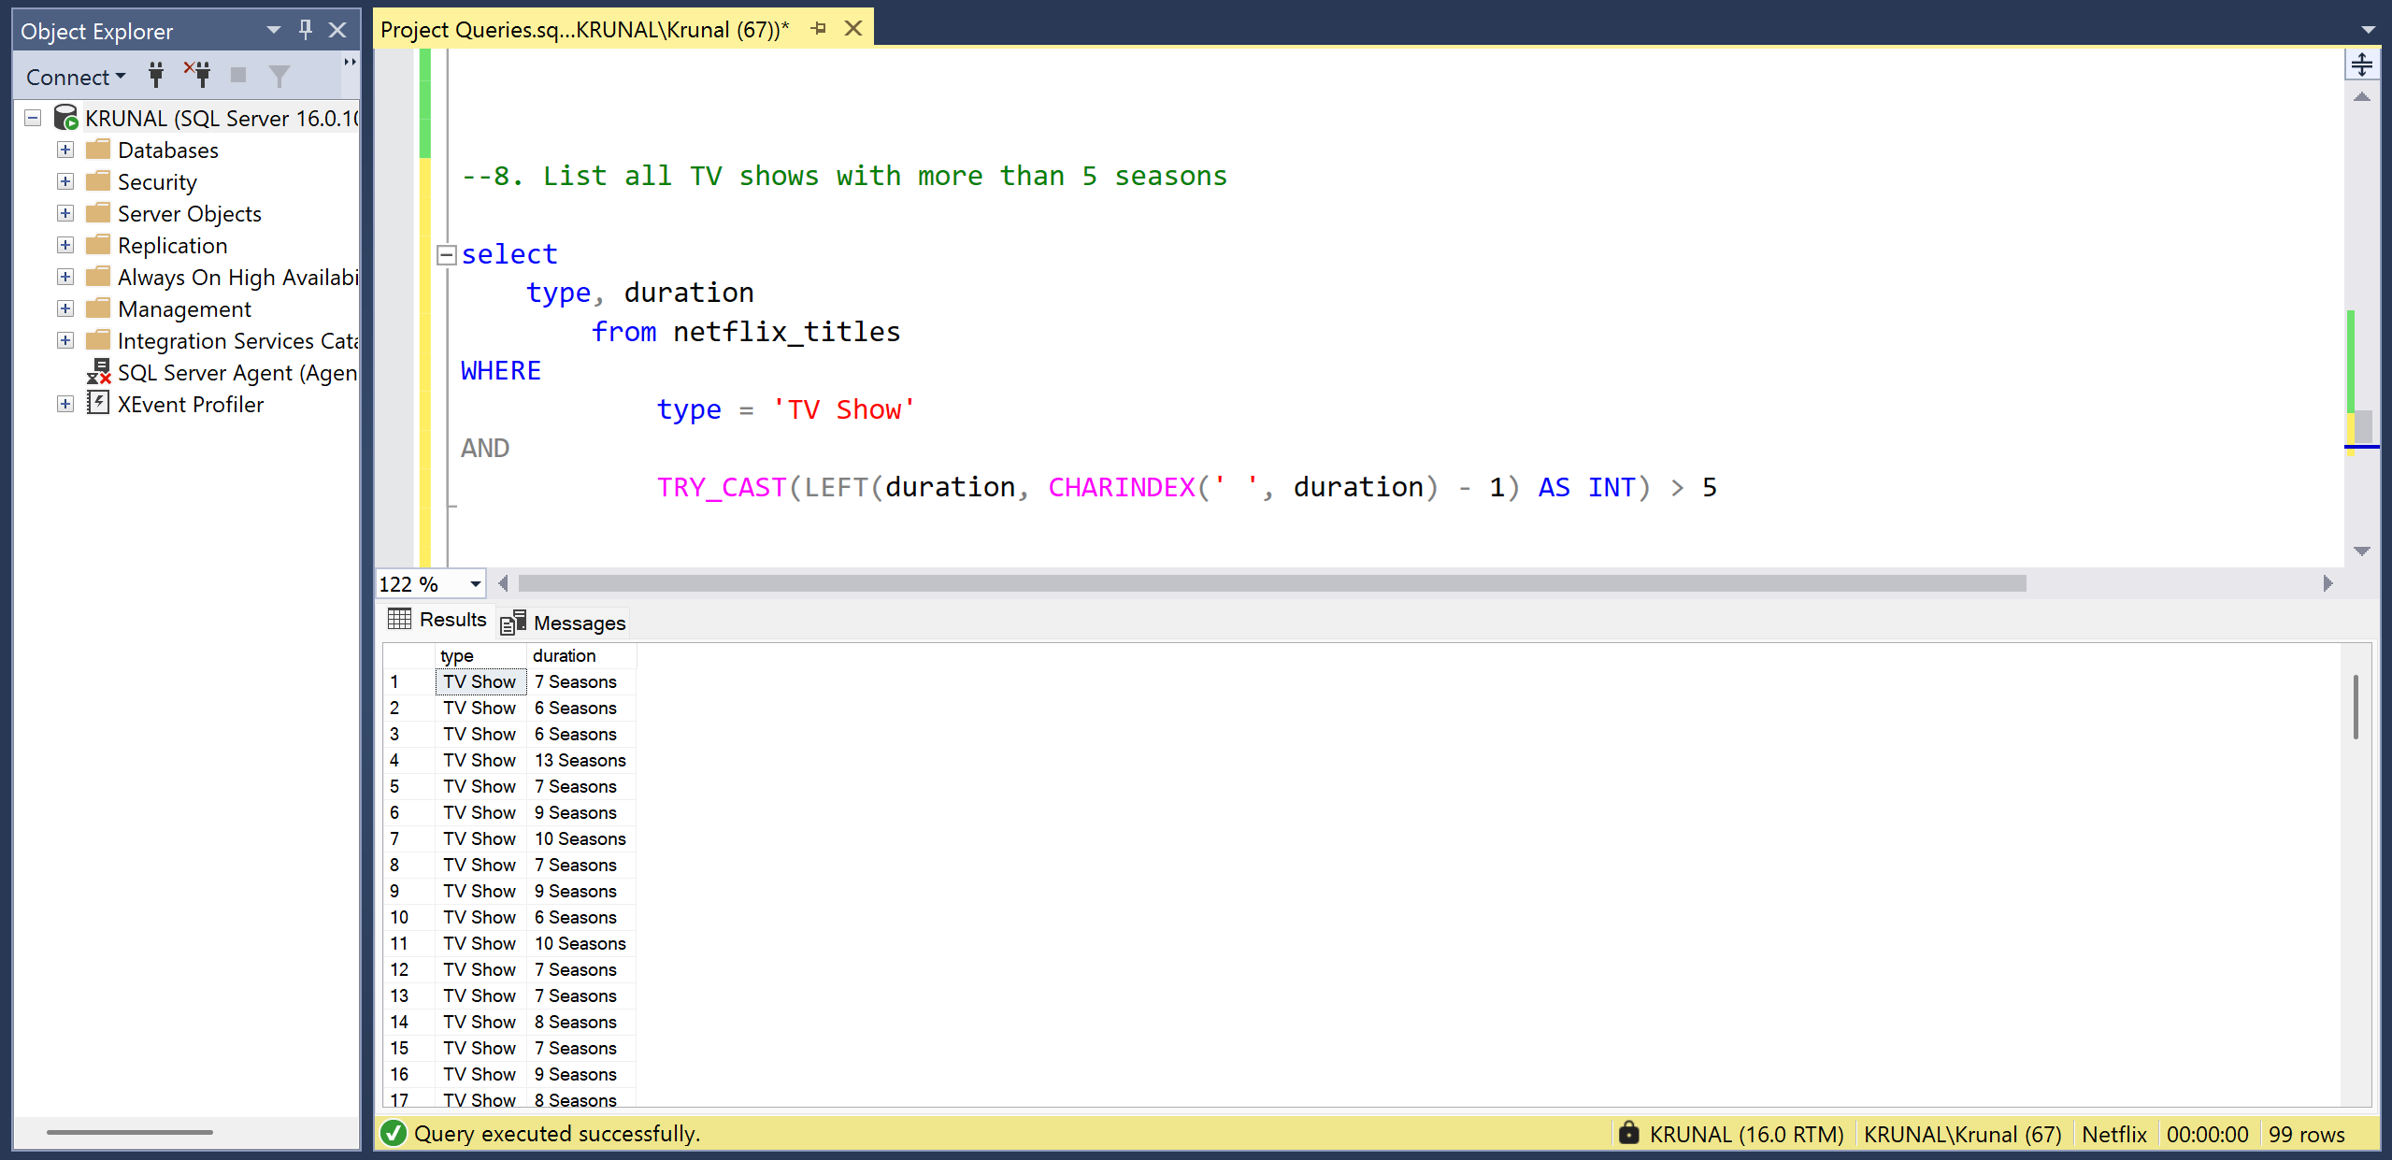

--9. Count the number of content items in each genre
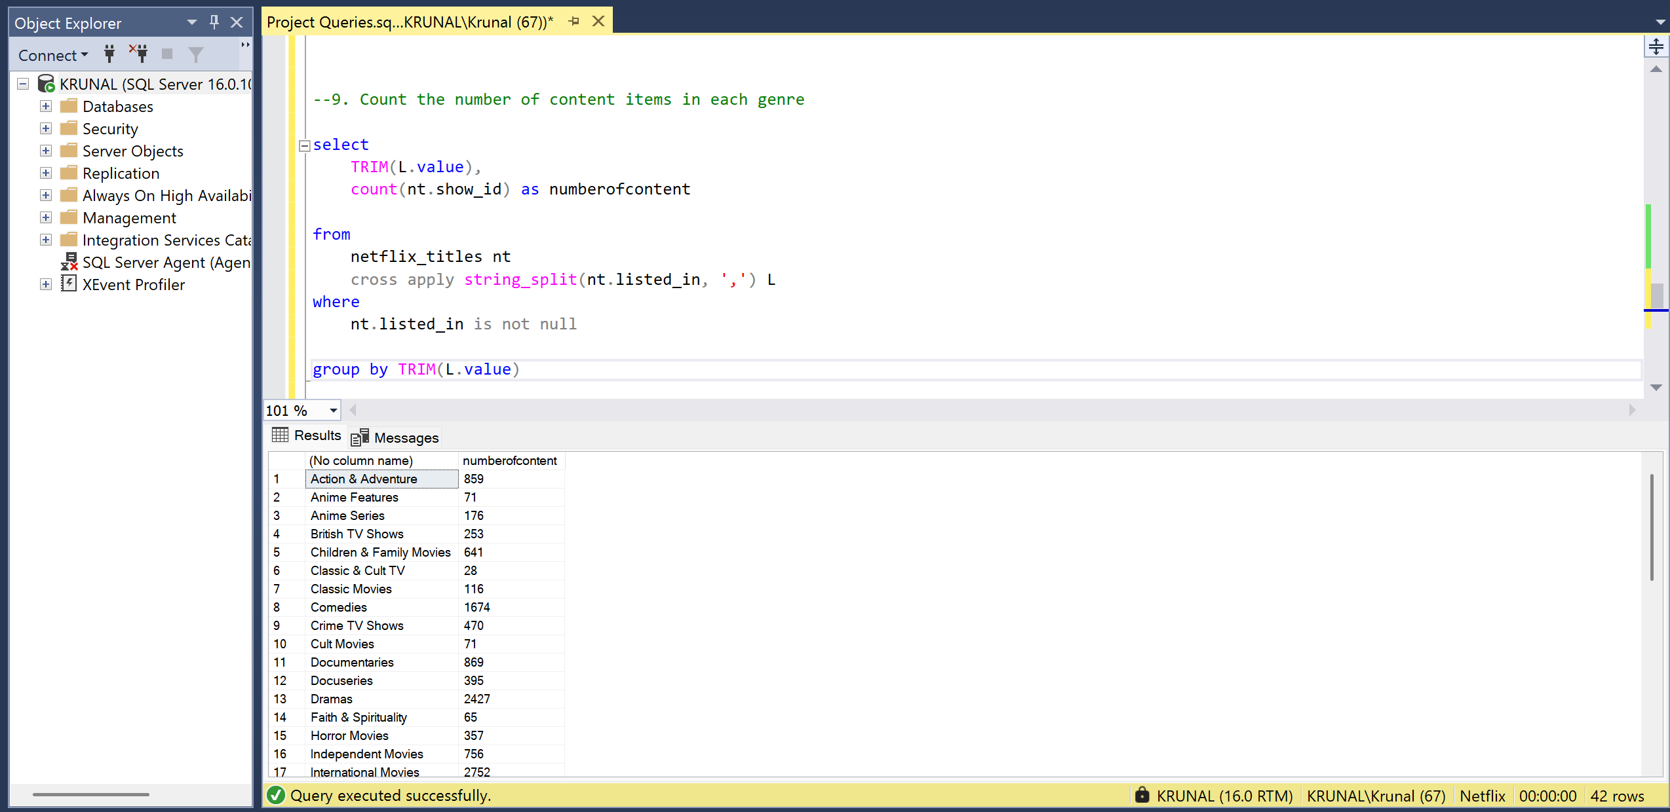

- --10.Find each year and the average numbers of content release in India on netflix. return top 5 year with highest avg content release!*/

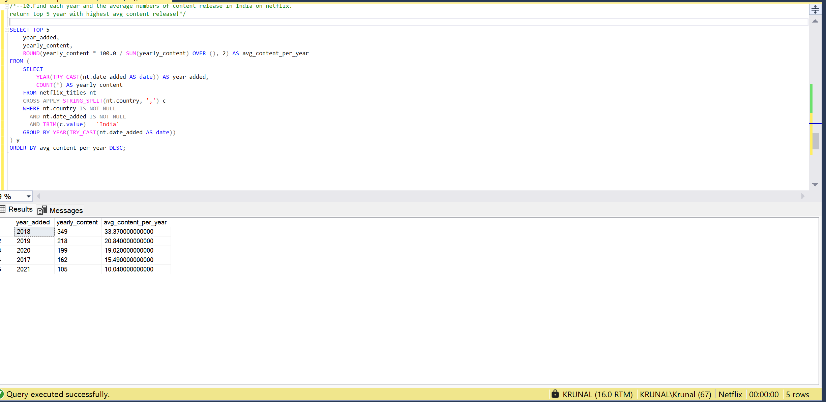

- --11. List all movies that are documentaries

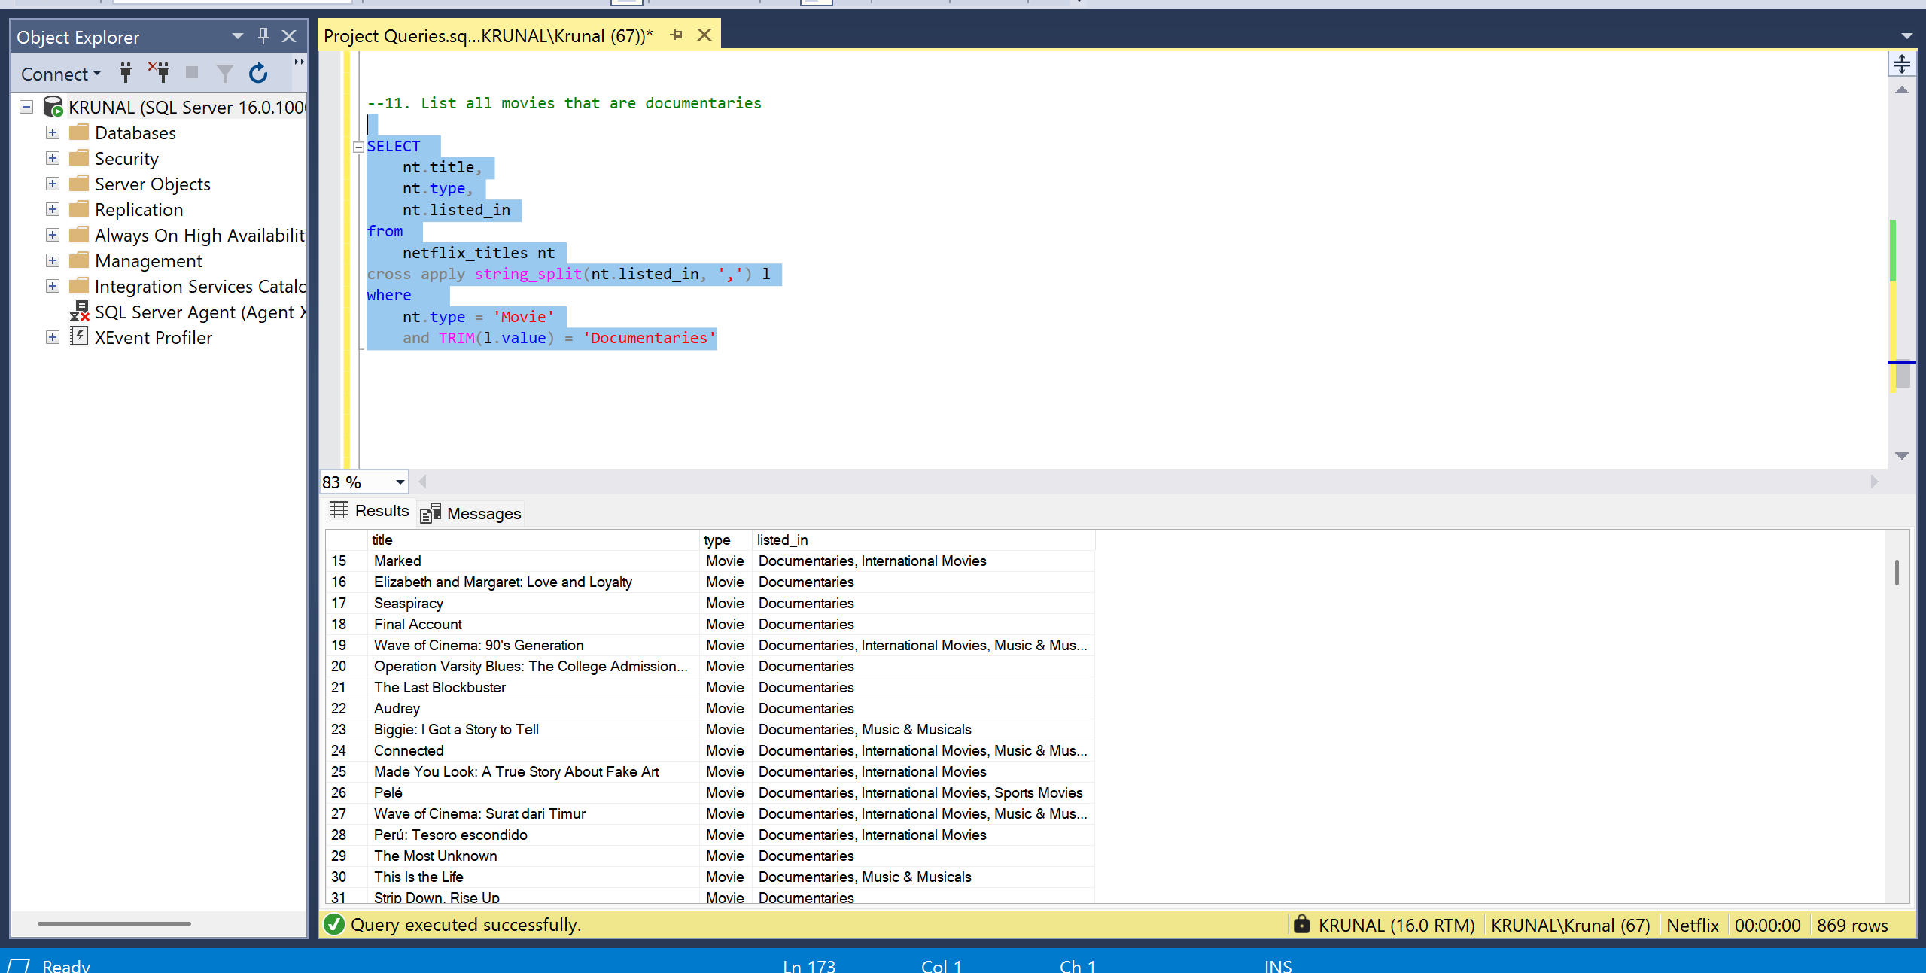

--12. Find all content without a director

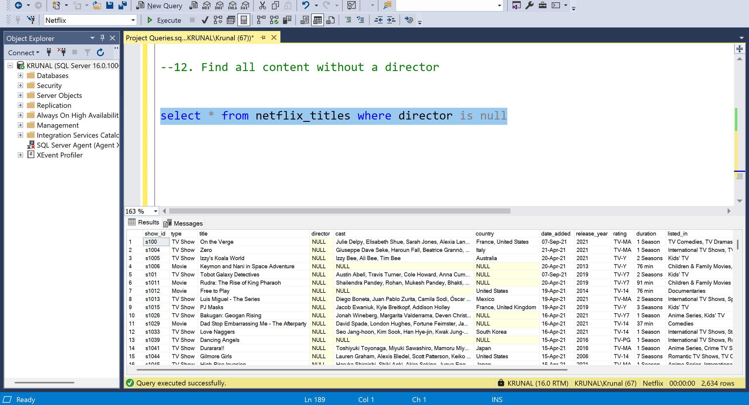

- --13. Find how many movies actor 'Salman Khan' appeared in last 10 years!

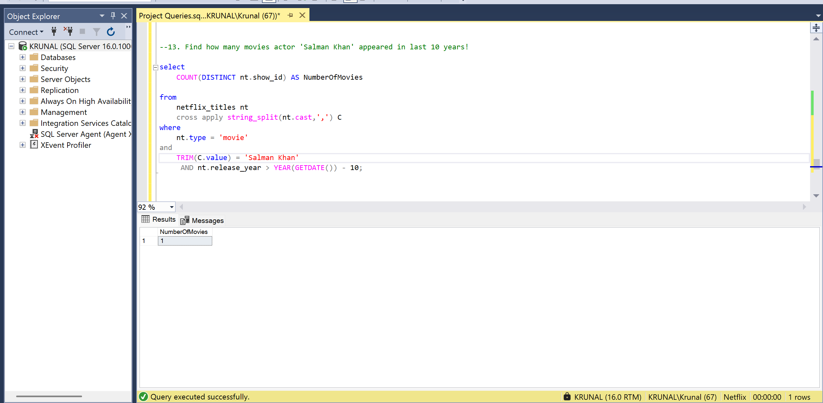

- --14. Find the top 10 actors who have appeared in the highest number of movies produced in India.

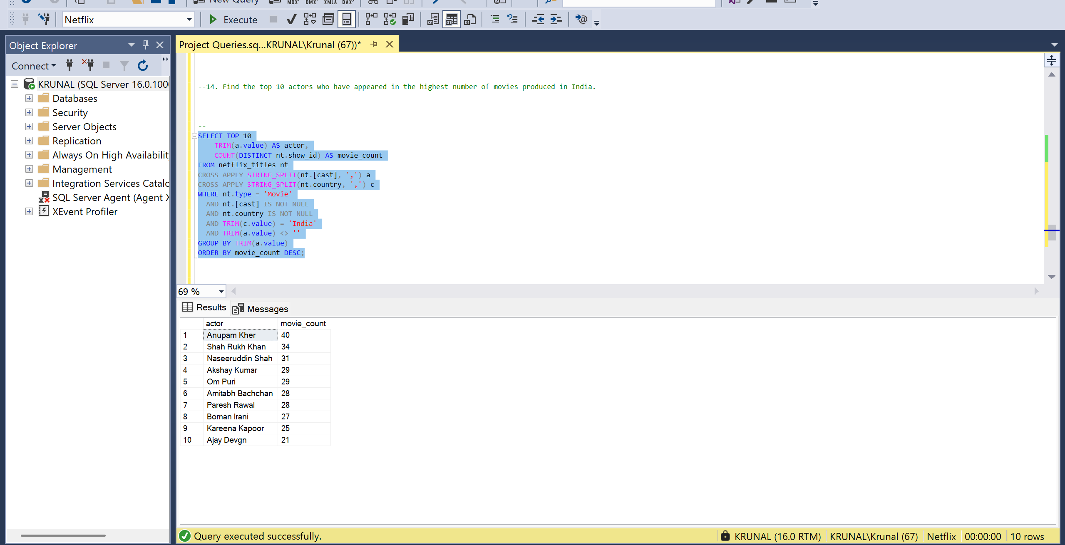

- /*15.
Categorize the content based on the presence of the keywords 'kill' and 'violence' in the description field. Label content containing these keywords as 'Bad' and all other content as 'Good'. Count how many items fall into each category.*/

